

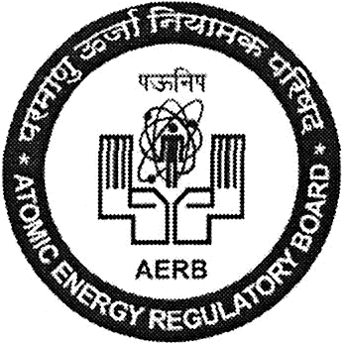
Institute for Plasma Research
4 41^{S}t DAE Safety & Occupational Health Professionals Meet
Bhat, Near Indira Bridge, Gandhinagar 382 428, Gujarat (India) Phone: +91-79-23962000/4006/4019 Fax: +91-79-23962277
Email: dsohpm2025@ipr.res.in

__________________________________________________________________________
NOMINATION FORM
__________________________________________________________________________

1. | Name of the Unit
2. | Name of the Plant/Site
3. | Name of Delegate
4. | Winner of Safety Competitions OR  Presenter of Contributory Paper
5. | Gender
6. | Date of Birth
7. | Designation/Level
8. | Address for Correspondence
9. | Mobile
10. | Email

Signature of the Participant Signature and Stamp of Head of Unit/plant

Shri Devendra Modi, IPR | Mrs. Saifali Sharma
Member Secretary, Technical Programme Committee Institute for Plasma Research  Near Indira Bridge, Bhat, Gandhinagar - 382 428, GUJARAT.  Tel: +91-79-2396 4006  Fax: +91-79-2396 2277  Email: dsohpm2025@ipr.res.in | Member Secretary, Local Organising Committee, Institute for Plasma Research  Near Indira Bridge, Bhat,  Gandhinagar - 382 428,  GUJARAT.  Tel: +91-79-2396 4019  Fax: +91-79-2396 2277  Email: dsohpm2025@ipr.res.in

